Things in:
[-] are the guidance section from specification
All words in bold are AS level so should be known how to do
#-# are from the content exemplification for enhanced content guidance (not in specification doc from another document from edexcel but essentially its more info about a subtopic) - from Issue 2 at january 2023

Calculator playlist -https://www.youtube.com/playlist?list=PLd7FwnU6nvjGNhznw0Zezrri_KShW9ybe

A LEVEL

1 Proof

1.1 Understand and use the structure of mathematical proof, proceeding from given assumptions through a series of logical steps to a conclusion; use methods of proof, including:

[Proof by deduction: proving results for arithmetic and geometric

series. ]

Proof by contradiction (including proof of the irrationality of $\sqrt{2}$ and the infinity of primes, and application to unfamiliar proofs).
#Candidates may have to choose the most appropriate method of tackling the proof#

Prove that √(2)$\sqrt{2}$ is irrational | 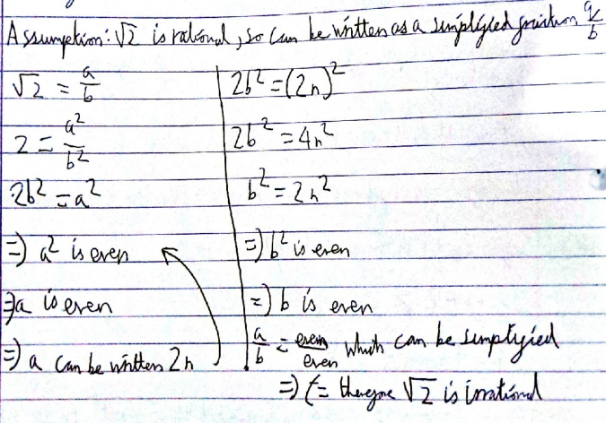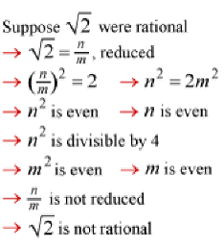

2 Algebra & Functions

2.6 Manipulate polynomials algebraically, including expanding brackets and collecting like terms, factorisation and simple algebraic division; use of the factor theorem. [Only division by (ax + b) or (ax – b) will be required. Students should know that if f(x) = 0 when x =$\frac{b}{a}$, then (ax – b) is a factor of f(x). Students may be required to factorise cubic expressions such as x³ + 3x² – 4 and 6x³ + 11x² – x – 6.]

Simplify rational expressions, including by factorising and cancelling, and algebraic division (by linear expressions only).

[Denominators of rational expressions will be linear or quadratic, $e.g. \frac{1}{ax+b}, \frac{ax+b}{px^{2}+qx+r},\frac{x^{3}+a^{3}}{x^{2}-a^{2}}$]

2.7 The modulus of a linear function.

[Students should be able to sketch the graph of $y = \left|ax+b\right|$ They should be able to use their graph. For example, sketch the graph with equation $y = \left|2x-1\right|$ and use the graph to solve the equation $\left|2x-1\right| = x$or the inequality $\left|2x-1\right|>x$]

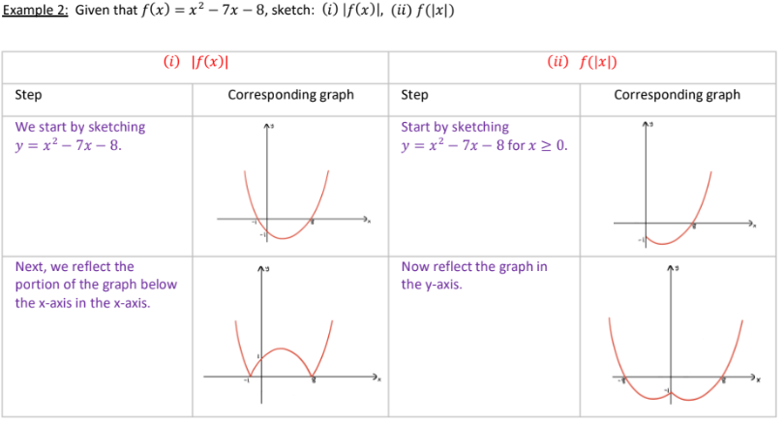
What does $y = \left|f(x)\right|$ do to a graph?  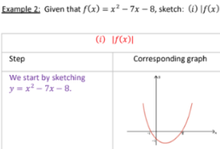 | It reflects all negative y values in the x axis to make them positive  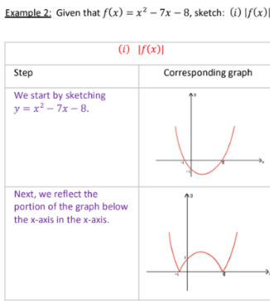
What does y = f(|x|) do to a graph?  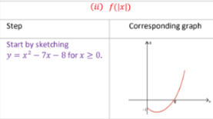 | It reflects all positive x values in the y axis to make them negative  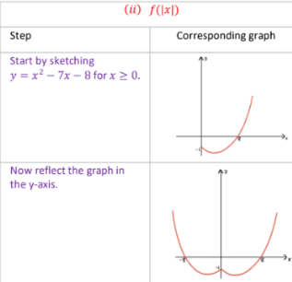

2.8 Understand and use composite functions; inverse functions and their graphs.

[The concept of a function as a one-one or many-one mapping from $R$ (or a subset of R) to R. The notation f : x and f(x) will be used. Domain and range of functions. Students should know that fg will mean ‘do g first, then f’ and that if f⁻¹ exists, then f⁻¹ f(x) = ff⁻¹(x) = x They should also know that the graph of y = f⁻¹(x) is the image of the graph of y = f(x) after reflection in the line y = x]

2.9 Understand the effect of simple transformations on the graph of y = f(x), including sketching associated graphs: y = af(x), y = f(x) + a, y = f(x + a), y = f(ax) and combinations of these transformations

[Students should be able to find the graphs of y = $\left|f(x)\right|$ and y = $\left|f(-x)\right|$, given the graph of y = f(x). Students should be able to apply a combination of these transformations to any of the functions in the A Level specification (quadratics, cubics, quartics, reciprocal, $\frac{a}{x^{2}}$, $\left|x\right|$, sinx, cosx, tanx, e^{x}, a^{x}) and sketch the resulting graph. Given the graph of y = f(x), students should be able to sketch the graph of, e.g. y = 2f(3x), or y = f(−x) + 1, and should be able to sketch (for example) y = 3 + sin 2x, y = − cos($x+\frac{π}{4}$ ) ]

#This may include the graph of y = f(ax + b).#

2.10 Decompose rational functions into partial fractions (denominators not more complicated than squared linear terms and with no more than 3 terms, numerators constant or linear).

[Partial fractions to include denominators such as (ax + b)(cx + d)(ex + f) and (ax + b)(cx + d)². Applications to integration, differentiation and series expansions.]

2.11 Use of functions in modelling, including consideration of limitations and refinements of the models.

[For example, use of trigonometric functions for modelling tides, hours of sunlight, etc. Use of exponential functions for growth and decay (see Paper 1, Section 6.7). Use of reciprocal function for inverse proportion (e.g. pressure and volume).]

3 Coordinate geometry in the (x,y) plane

3.3 Understand and use the parametric equations of curves and conversion between Cartesian and parametric forms.

[For example: x = 3cost, y = 3sin t describes a circle centre O radius 3 x = 2 + 5cost, y = −4 + 5sint describes a circle centre (2, −4) with radius 5. x = 5t, y = $\frac{5}{t}$ describes the curve xy = 25 (or y = $\frac{25}{x}$). x = 5t, y = 3t2 describes the quadratic curve 25y = 3x2 and other familiar curves covered in the specification. Students should pay particular attention to the domain of the parameter t, as a specific section of a curve may be described.]

#Students may be required to sketch a graph which is defined by its parametric equations. For example: $x=t^{2}, y=t^{3}, tϵℜ or x=2+3cosθ, y =4+3sinθ, 0≤θ≼2π$#

3.4 Use parametric equations in modelling in a variety of contexts.

[A shape may be modelled using parametric equations or students may be asked to find parametric equations for a motion. For example, an object moves with constant velocity from (1, 8) at t = 0 to (6, 20) at t = 5. This may also be tested in Paper 3, section 7 (kinematics).]

4 Sequences and series

4.1 Understand and use the binomial expansion of (a + bx)n for positive integer n; the notations n! and $n⊂r$ link to binomial probabilities.

[Use of Pascal’s triangle. Relation between binomial coefficients. Also be aware of alternative notations such as $(\frac{n}{r})$ and $n⊂r$ Considered further in Paper 3 Section 4.1 ]

Extend to any rational n, including its use for approximation; be aware that the expansion is valid for $\left|\frac{bx}{a}\right|<1$ (proof not required) [May be used with the expansion of rational functions by decomposition into partial fractions May be asked to comment on the range of validity.]
What suitable value for x should you use for binomial questions that ask for an approximation? E.g 6C  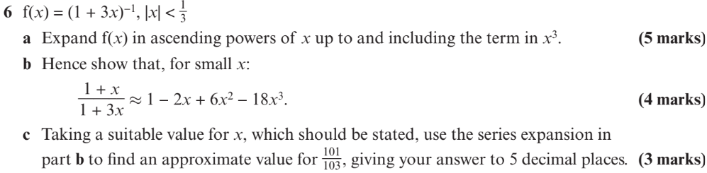 | 0.01

4.2 Work with sequences including those given by a formula for the nth term and those generated by a simple relation of the form x_{n + 1} = f(x_{n}); increasing sequences; decreasing sequences; periodic sequences.[For example $u_{n}=\frac{1}{3n+1}$ describes a decreasing sequence as u_{n + 1} < u_{n} for all integer n $u_{n}=2^{n }$is an increasing sequence as u_{n + 1} > u_{n} for all integer n u_{n + 1} = $\frac{1}{u_{n}}$for n > 1 and u₁ = 3 describes a periodic sequence of order 2]

What are the 3 types of sequences? | - Increasing - U_{n + 1} > U_{n}  - Decreasing - U_{n + 1} < U_{n}  - Periodic - U_{n + a} = U_{n} (usually has some trig function)

4.3 Understand and use sigma notation for sums of series. [Knowledge that $\sum_{1}^{n}{}1=n$ is expected]

4.4 Understand and work with arithmetic sequences and series, including the formulae for nth term and the sum to n terms.

[The proof of the sum formula for an arithmetic sequence should be known including the formula for the sum of the first n natural numbers.]
What are all the arithmetic sequences formulae? | 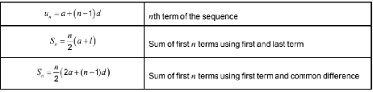  Where a = first term, L = last term, d = difference
Derive the arithmetic series formula | 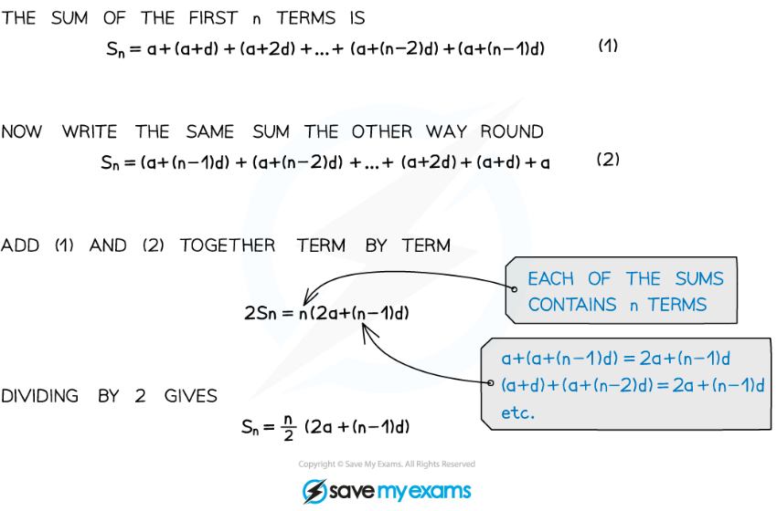  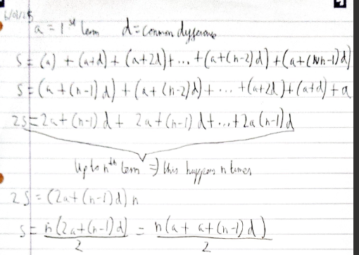

4.5 Understand and work with geometric sequences and series, including the formulae for the nth term and the sum of a finite geometric series; the sum to infinity of a convergent geometric series, including the use of | r | < 1; modulus notation

[The proof of the sum formula should be known. Given the sum of a series students should be able to use logs to find the value of n. The sum to infinity may be expressed as S∞]
What are all the geometric sequences formulae? | 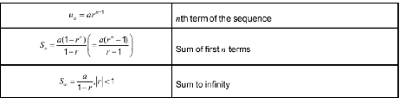  Where a = first term, r = common ratio
Derivation of geometric series formula Sn=a(r^{n}-1)/r-1 | 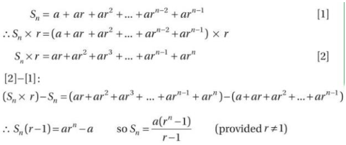  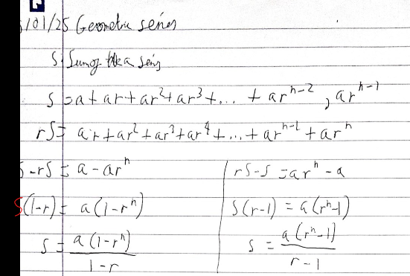

4.6 Use sequences and series in modelling.

[Examples could include amounts paid into saving schemes, increasing by the same amount (arithmetic) or by the same percentage (geometric) or could include other series defined by a formula or a relation.]

5 Trigonometry

5.1 Understand and use the definitions of sine, cosine and tangent for all arguments; the sine and cosine rules; the area of a triangle in the form 0.5xaxbxsinC

[Use of x and y coordinates of points on the unit circle to give cosine and sine respectively, including the ambiguous case of the sine rule.]

Work with radian measure, including use for arc length and area of sector.

[Use of the formulae s = rθ and A =0.5r²θ for arc lengths and areas of sectors of a circle.]
What is the equation for the arc length in degrees? | 𝚹/360 x πd
What is the equation for the arc length in radians? | r𝚹 (𝚹/2π x 2πr)
What is the equation for the area of a sector in degrees? | 𝚹/360 x πr2
What is the equation for the area of a sector in radians? | 0.5r2𝚹 (𝚹/2π x πr²)
What is the equation for the area of a segment in radians? 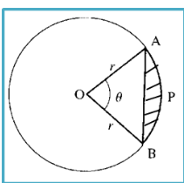 | - 0.5r2(𝚹-sin𝚹)  - 0.5r2𝚹 - 0.5r2sin𝚹  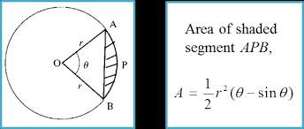

5.2 Understand and use the standard small angle approximations of sine, cosine and tangent sinθ ≈ θ, $cosθ≈1-\frac{θ^{2}}{2}$, tanθ ≈ θ Where θ is in radians.

[Students should be able to approximate,e.g. $\frac{cos3x-1}{xsin4x}$when x is small, to $-\frac{9}{8}$]
Stated we are using small angle approximation what is the approximation for sinΘ? | sinΘ ≈ Θ
Stated we are using small angle approximation what is the approximation for cosΘ? | cosΘ ≈ 1 - $\frac{θ^{2}}{2}$
Stated we are using small angle approximation what is the approximation for tanΘ? | tanΘ ≈ Θ

5.3 Know and use exact values of sin and cos for $0,\frac{π}{6},\frac{π}{4},\frac{π}{3},\frac{π}{2}, π$and multiples thereof, and exact values of tan for $0,\frac{π}{6},\frac{π}{4},\frac{π}{3},π$and multiples thereof

5.4 Understand and use the definitions of secant, cosecant and cotangent and of arcsin, arccos and arctan; their relationships to sine, cosine and tangent; understanding of their graphs; their ranges and domains.

[Angles measured in both degrees and radians.]

5.5 Understand and use $tanΘ=\frac{sinΘ}{cosθ}$ Understand and use$sin^{2}θ+cos^{2}θ = 1$

[These identities may be used to solve trigonometric equations and angles may be in degrees or radians. They may also be used to prove further identities.]

sec²θ = 1 + tan²θ and cosec²θ = 1 + cot²θ
What is the trigonometric identity with sec2(x) | Sec²x = 1 + tan²x
What is the trigonometric identity with cosec2(x) | Cosec²x = 1 + cot²x

5.6 Understand and use double angle formulae; use of formulae for sin (A ± B), cos (A ± B), and tan (A ± B), understand geometrical proofs of these formulae. Understand and use expressions for acosθ + bsinθ in the equivalent forms of r cos (θ α± ) or rsin (θ±α)

[To include application to half angles. Knowledge of the $tan(\frac{1}{2}θ)$ formulae will not be required. Students should be able to solve equations such as a cos θ + b sin θ = c in a given interval.]
What is the equation for the double angle formula of sin(2A) | Sin(2A) = 2sinAcosA
What are the 5 equations for the double angle formulae of cos(2A) | - Cos(2A) = cos²(A) - sin²⁽A)  - Cos(2A) = 2cos²(A) - 1  - Cos(2A) = 1 - 2sin²(A)  - Sin²(A) = 0.5 - 0.5cos(2A)  - cos²(A) = 0.5cos(2A) + 1
What is the equations for the double angle formula of tan(2A) | tan(2A) = 2tanA/1-tan²(A)

5.7 Solve simple trigonometric equations in a given interval, including quadratic equations in sin, cos and tan and equations involving multiples of the unknown angle.

[Students should be able to solve equations such as $sin (x + 7{0^{∘})=0.5 for 0<x< 360^{∘}, 3 + 5 cos2x = }_{}$$= 1 for-180^{∘}<x< 180^{∘} 6 cos^{2}x +sinx-5=0,0<=x<360^{∘}$]

These may be in degrees or radians and this will be specified in the question.

5.8 Construct proofs involving trigonometric functions and identities. Students need to prove identities such as cos x cos 2x + sin x sin 2x ≡ cos x.

5.9 Use trigonometric functions to solve problems in context, including problems involving vectors, kinematics and forces.

[Problems could involve (for example) wave motion, the height of a point on a vertical circular wheel, or the hours of sunlight throughout the year. Angles may be measured in degrees or in radians.]

6 Exponentials & Logarithms

6.1 Know and use the function e^{x} and its graph. [To include the graph of y = e^{ax + b} + c]

7 Differentiation

7.1 Differentiation from first principles for small positive integer powers of x and for sin x and cos x. Understand and use the second derivative as the rate of change of gradient; connection to convex and concave sections of curves and points of inflection.

[Know that at an inflection point f ′′(x) changes sign. Consider cases where f ′′(x) = 0 and f′(x) = 0 where the point may be a minimum, a maximum or a point of inflection (e.g. y = x^{n} , n > 2)]

#A function is concave on a given interval if f ′′(x) < 0 (or f ′′(x) ≤ 0 for all values of x in that interval. A function is convex on a given interval if f ′′(x) > 0 (or f ′′(x) ≥ 0 ) for all values of x in that interval. A point of inflection is a point where f ′′(x) changes sign.#
What is the differentiation of dy/dx of sinx | cosx
What is the differentiation of dy/dx of cosx | -sinx

7.2 Differentiate e^{kx} and a^{kx}, sin kx, cos kx, tan kx and related sums, differences and constant multiples. Understand and use the derivative of ln x.

[Knowledge and use of the result $\frac{d}{dx}(a^{kx})=ka^{kx}ln a$ is expected.]
What is the differentiation of dy/dx of lnx | 1/x
What is the differentiation of dy/dx of lnkx | 1/x
What is the differentiation of dy/dx of a^{x} | a^{x}lna
What is the differentiation of dy/dx of a^{kx} | a^{kx}klna

7.3 Apply differentiation to find gradients, tangents and normals maxima and minima, stationary points AND POINTS OF interflection

7.4 Differentiate using the product rule, the quotient rule and the chain rule, including problems involving connected rates of change and inverse functions.

[Differentiation of cosec x, cot x and sec x. Differentiation of functions of the form x = sin y, x = 3 tan 2y and the use of $\frac{dy}{dx}=\frac{1}{(\frac{dx}{dy})}$ Use of connected rates of change in models, e.g. $\frac{dV}{dx}=\frac{dV}{dr}×\frac{dr}{dt}$ Skill will be expected in the differentiation of functions generated from standard forms using products, quotients and composition, such as 2x⁴ sin x, $\frac{e^{3x}}{x}$, cos²x and tan²2x]

7.5 Differentiate simple functions and relations defined implicitly or parametrically, for first derivative only.

[The finding of equations of tangents and normals to curves given parametrically or implicitly is required.]

#Students are not required to differentiate functions such as y = arcsin x or $y=\frac{1}{3}arctan x$ , but they may be asked to differentiate implicitly functions such as $x=sin y$ or $x=tan 3y$ #

7.6 Construct simple differential equations in pure mathematics and in context, (contexts may include kinematics, population growth and modelling the relationship between price and demand).

[Set up a differential equation using given information. For example: In a simple model, the rate of decrease of the radius of the mint is inversely proportional to the square of the radius.]

8 Integration

8.2 Integrate e^{kx}, $\frac{1}{x}$, sinkx, coskx and related sums, differences and constant multiples.

[To include integration of standard functions such as sin 3x, sec² 2x, tan x, e^{5x}, $\frac{1}{2x}$Students are expected to be able to use trigonometric identities to integrate, for example, sin² x, tan² x, cos² 3x.]

#Students are expected to be able to use the integrals of the standard functions given in the formula booklet.#

8.3 Evaluate definite integrals; use a definite integral to find the area under a curve and the area between two curves.

[Students will be expected to be able to evaluate the area of a region bounded by a curve and given straight lines, or between two curves. This includes curves defined parametrically. Or find the finite area bounded by the curve y = x² – 5x + 6 and the curve y = 4 – x²]

#Students are expected to integrate (to find areas) using the parametric equations. It is acceptable to convert from parametric to Cartesian form before integrating, but this may lead to much more complicated integrals.#
What is the equation needed to find the area of a graph (Integrate) through parametric equations where y and x is in terms of t | $∫y \frac{dx}{dt} dt$

8.4 Understand and use integration as the limit of a sum. [Recognise $\int_{a}^{b}{}f(x) dx = \lim_{δx→0}\sum_{x=a}^{b}{}f(x) δx$]

# Students may be asked to calculate $\lim_{δx→0}\sum_{x=a}^{b}{}f(x)δx$ for a given function and they are expected to recognise that this is equal to $\int_{a}^{b}{}f(x)dx$ for that function.#

8.5 Carry out simple cases of integration by substitution and integration by parts; understand these methods as the inverse processes of the chain and product rules respectively (Integration by substitution includes finding a suitable substitution and is limited to cases where one substitution will lead to a function which can be integrated; integration by parts includes more than one application of the method but excludes reduction formulae.)

[Students should recognise integrals of the form$\int{}\frac{f'(x)}{f(x)}dx = ln f(x)+c.$ The integral $\int{}ln x dx$is required ]

#Students are expected to know how to integrate functions such as tan kx, cot kx and sin³x cos x; they can be thought of as ‘function and derivative’ or reverse chain rule types where students are expected to think of integration as the opposite of differentiation.#

8.6 Integrate using partial fractions that are linear in the denominator.

[Integration of rational expressions such as those arising from partial fractions, e.g.$\frac{2}{3x+5}$Note that the integration of other rational expressions, such as $\frac{x}{x^{2}+5}and\frac{2}{(2x-1)^{4}}$is also required (see previous paragraph 8.5)]

8.7 Evaluate the analytical solution of simple first order differential equations with separable variables, including finding particular solutions (Separation of variables may require factorisation involving a common factor.)

[Students may be asked to sketch members of the family of solution curves.]

8.8 Interpret the solution of a differential equation in the context of solving a problem, including identifying limitations of the solution; includes links to kinematics.

[The validity of the solution for large values should be considered.]

9 Numerical methods

9.1 Locate roots of f(x) = 0 by considering changes of sign of f(x) in an interval of x on which f(x) is sufficiently well behaved. Understand how change of sign methods can fail.

[Students should know that sign change is appropriate for continuous functions in a small interval. When the interval is too large sign may not change as there may be an even number of roots. If the function is not continuous, sign may change but there may be an asymptote (not a root).]

#When concluding there is a root, students should state the function is continuous, but they do not need to demonstrate this.#
What general statement should be said to conclude numerical method questions within a small interval? | There is a change of sign over the continuous part of the function therefore there is a root between x and y

9.2 Solve equations approximately using simple iterative methods; be able to draw associated cobweb and staircase diagrams.

[Understand that many mathematical problems cannot be solved analytically, but numerical methods permit solution to a required level of accuracy. Use an iteration of the form x_{n + 1} = f (x_{n}) to find a root of the equation x = f (x) and show understanding of the convergence in geometrical terms by drawing cobweb and staircase diagrams.]

9.3 Solve equations using the Newton-Raphson method and other recurrence relations of the form x_{n+1}= g(x_{n}) Understand how such methods can fail.

[For the Newton-Raphson method, students should understand its working in geometrical terms, so that they understand its failure near to points where the gradient is small.]

#Students should be aware that when the gradient is zero, the tangent to the curve will not meet the x-axis and therefore the method fails.#

9.4 Understand and use numerical integration of functions, including the use of the trapezium rule and estimating the approximate area under a curve and limits that it must lie between.

[For example, evaluate $\int_{0}^{1}{}\sqrt{(2x+1)} dx$ using the values of $\sqrt{(2x+1) }$at x = 0, 0.25, 0.5, 0.75 and 1 and use a sketch on a given graph to determine whether the trapezium rule gives an over-estimate or an under-estimate.]

#The trapezium rule is the only numerical method of integration required in this specification. Students may be told either the number of strips to use or the width of the strips.#

9.5 Use numerical methods to solve problems in context.

[Iterations may be suggested for the solution of equations not soluble by analytic means.]

#Questions will always state when iterative methods are required.#

10 Vectors

10.1 Use vectors in two dimensions and in three dimensions

[Students should be familiar with column vectors and with the use of i and j unit vectors in two dimensions and i, j and k unit vectors in three dimensions]

# Questions may be set in two dimensions and three dimensions#

10.4 Understand and use position vectors; calculate the distance between two points represented by position vectors.

[In three dimensions, the distance d between two points (x₁ , y₁ , z₁) and (x₂ , y₂ , z₂) is given by d² = (x₁ – x₂)² + (y₁ – y₂)² + (z₁ – z₂)²]

# Questions may be set in two dimensions and three dimensions#

